WD Diploma - Capstone Project

**Project Title:** *Magnus*

**Author:** *Kingsley Memeh*

**Cohort:** *Winter 2022*

## Project Overview

### 1.1 Description

Magnus is a prototype on-demand streaming platform. For this version, the platform will use The Movie Database to populate the app with movie/tv information. Ultimately the platform will be THE place to consume African film and television.

### 1.2 Problem*.*

While there is no inherent problem with the current streaming space. I felt that there was no platform indigenous to the African film industry that was catered towards promoting the aura of African content.

### 1.3 User Profile

The user will be any one interested in on-demand streaming, most importantly African film and television.

### 1.4 Requirements: Use Cases and Features

Magnus should effectively do the following in version 1:

1. Allow users the ability to view and interact with a curating list of films and television

### 1.5 Tech Stack and APIs

*Version 1:*

* React
* SAAS
* AXIOS

*Version 2:*

* *All technology utilized above*
* *Node.js*
* *Passport.js*
* *MongoDB*
* *Firebase*

## 2. Client-Side Implementation

### Site Map

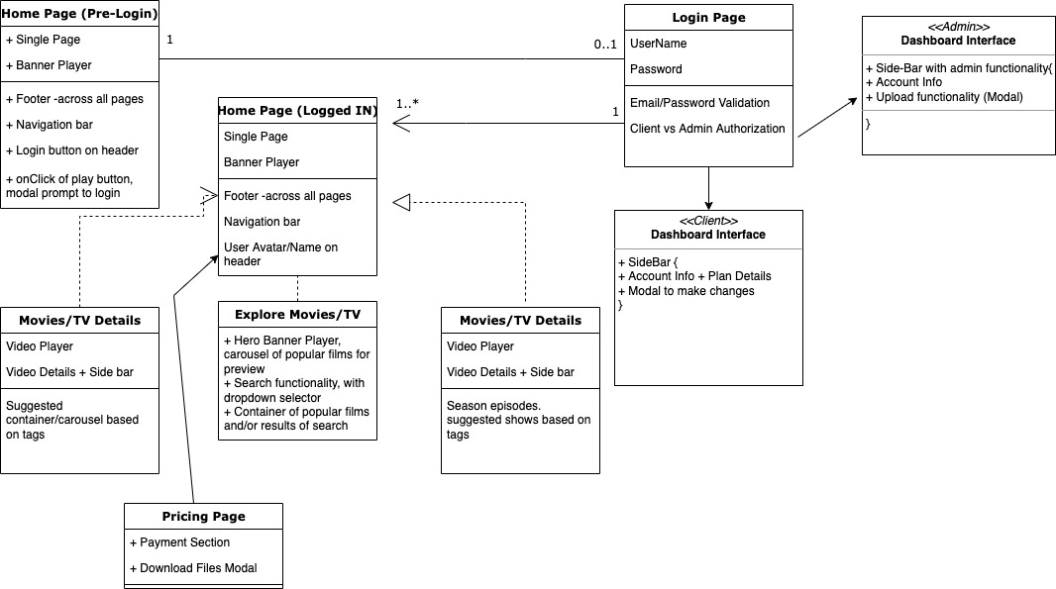

### Screen Details

 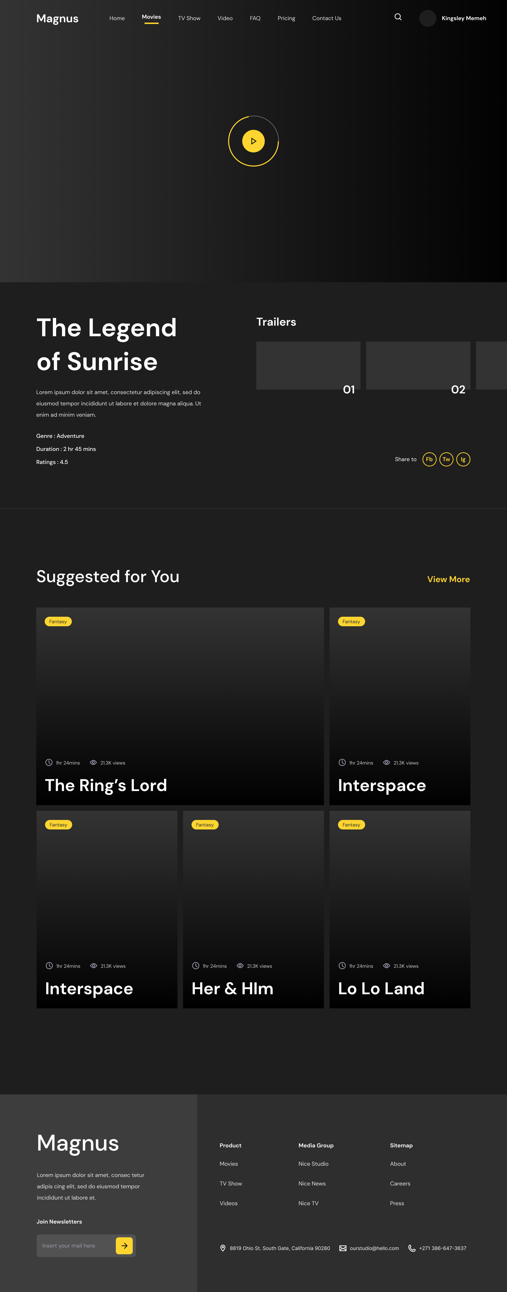 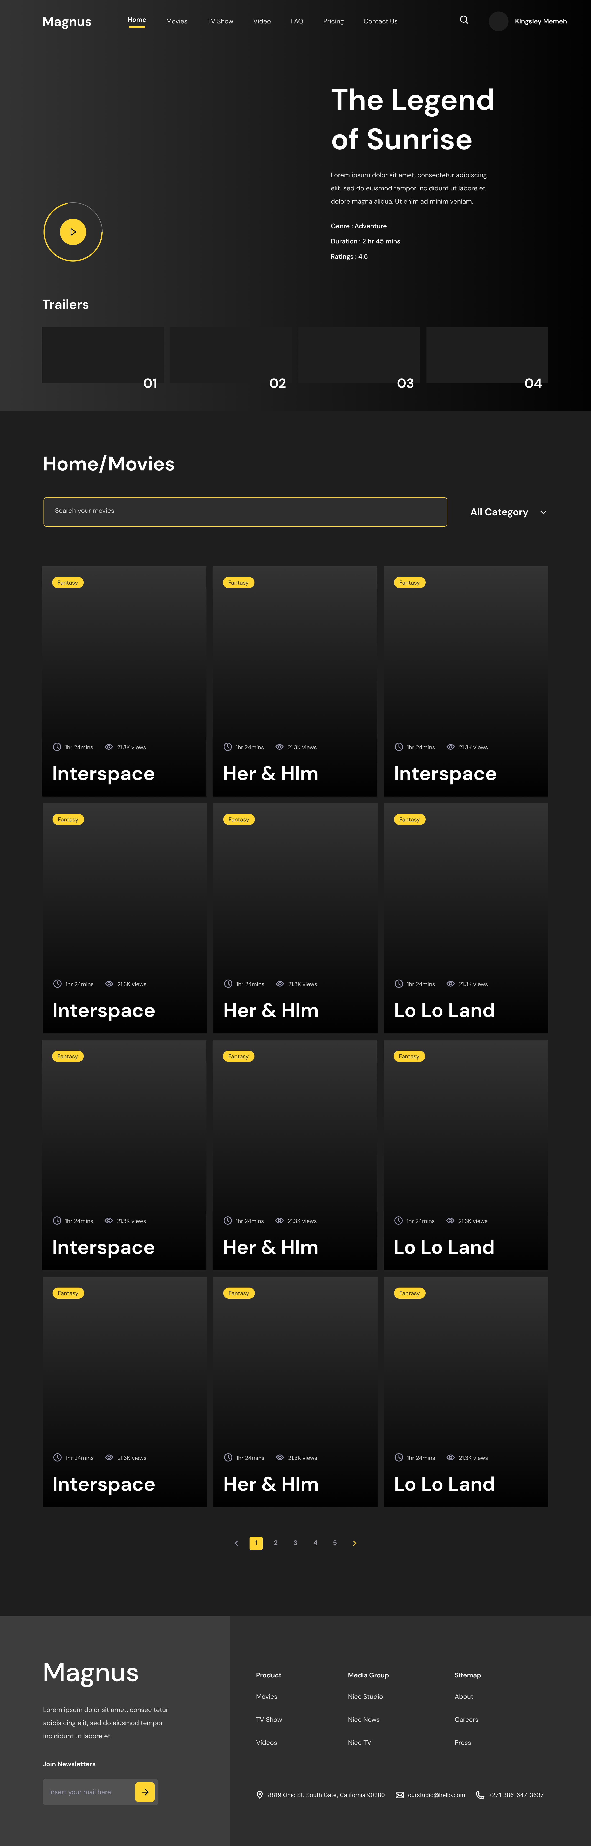

## 3. Server-Side Implementation

### 3.1 End-Point Descriptions

|  |  |
| --- | --- |
| **End-point** | **Response Format** |
| *HTTP GET - /movie/<movie.id>/reviews* | *{ reviews : [ { author : ‘STRING’, content : ‘STRING’, ID : NUMBER, date_created: ‘STRING’ } … ] }* |
| *HTTP GET - /movie/<movie.id>* | *{ results : [ { title : ‘STRING’, description : ‘STRING’, ID : NUMBER, date_added: ‘STRING’, year: ‘STRING’ , cast;[{name: STRING, character: STRING, profile_image: STRING}]} … ] }* |
|  |  |

### 3.2 External APIs that will be consumed

* TMDB